COLLABORATIVE LIFECYCLE MANAGEMENT (CLM)

**Rational solution for Collaborative Lifecycle Management** (CLM) is an integrated Application Lifecycle Management solutioncomprising four products: [Rational Requirements Composer](http://en.wikipedia.org/w/index.php?title=Rational_Requirements_Composer&action=edit&redlink=1), Rational Team Concert, Rational Quality Manager and Rational Software Architect Design Manager. CLM is developed by the Rational brand of IBM and was first released in 2011. CLM is used to coordinate software development activities across business and system requirements, design, development, build, test, and delivery.

HOW TO CREATE A LIFE-CYCLE PROJECT IN CLM?

1. Logon to the Jazz Team Server Administration home page ([*https://inbasdpc06348.techmahindra.com:9443/jts/*](https://inbasdpc06348.techmahindra.com:9443/jts/)) as a user who has JazzAdmins repository permissions and the following client access licenses:
   * + - 1. Rational Quality Manager - Quality Professional
         2. Rational Team Concert - Developer
2. Click on **Manage Lifecycle Project,** to go to the **All Lifecycle Project** page.

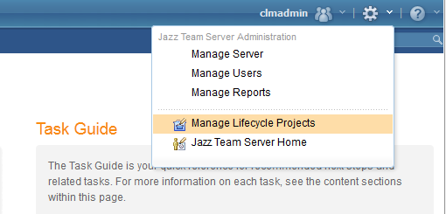

1. In **All Lifecycle Project** page click on **Create Lifecycle Project**. 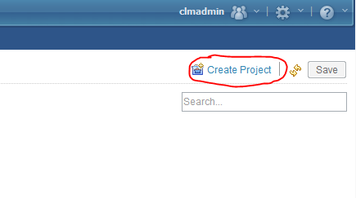
2. Enter a name, such as **Demo Project**. In the **Template** field, select **Quality Professional, Analyst, Developer – with Design Management**, this creates project areas in the quality management, change and configuration management and design management applications.

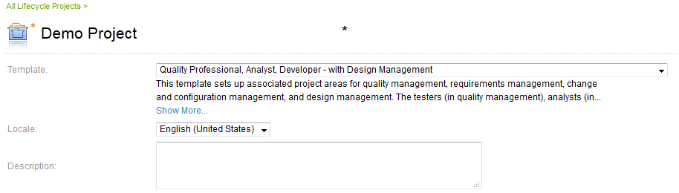

By default each project area is named based on the lifecycle project name. For example: **Demo Project (Change Management)**. You can specify different names by editing them in the **Artifact Containers** section.

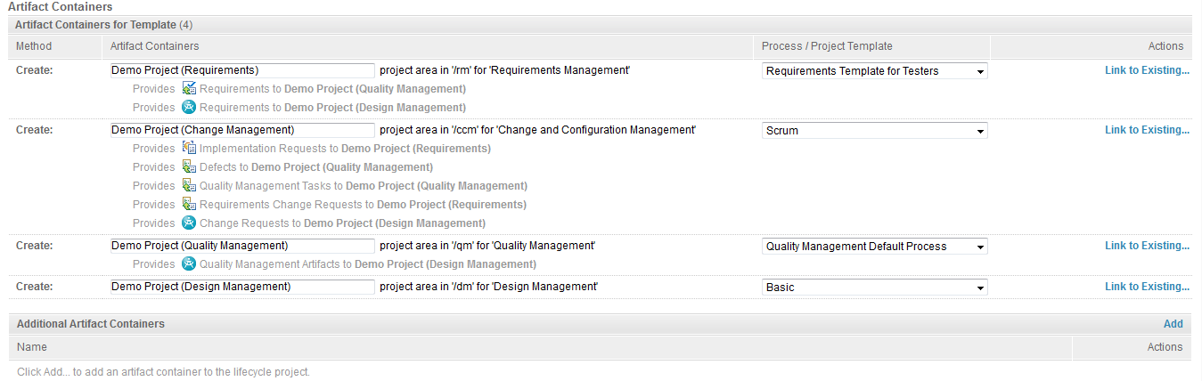

Click **Save**.

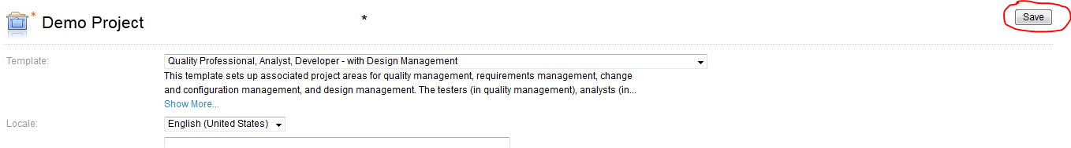

CHANGE MANAGEMENT

After creating the Lifecycle project click on **Demo Project (Change Management)** to move to Change Management project area.

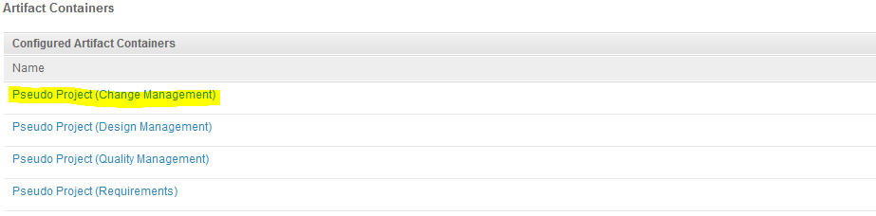

The Change Management project area will look similar to the view below:

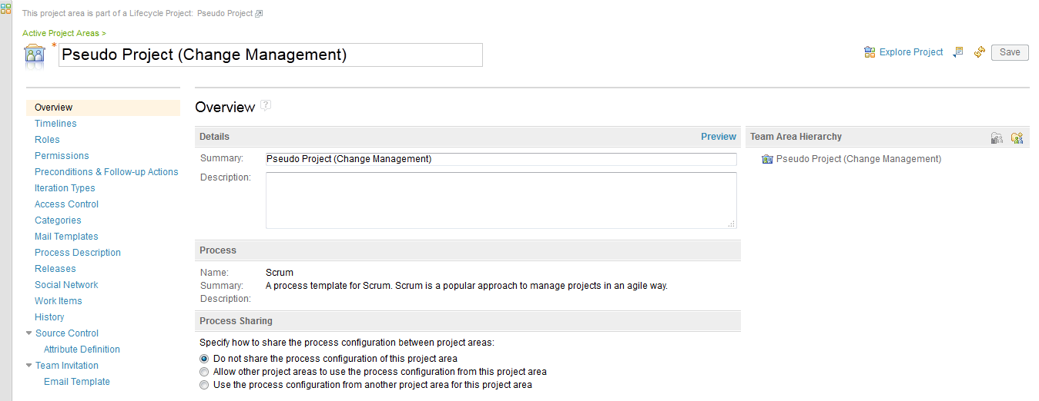

ADDING MEMBERS AND ASSIGNING ROLES TO THEM

In project area scroll down till the member section (as shown below) and click on **Add…** to add members to your change management life cycle project.

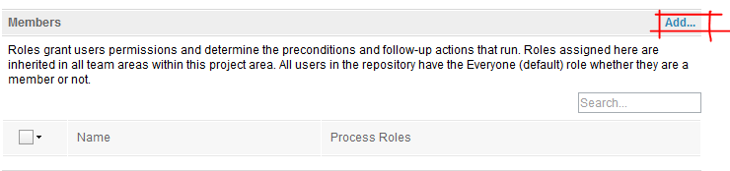

1. After clicking on **Add...** option **Add New Member** window will pop-up (shown in the below image). Type a name filter to load the user list, from where you will add a member to your project area.

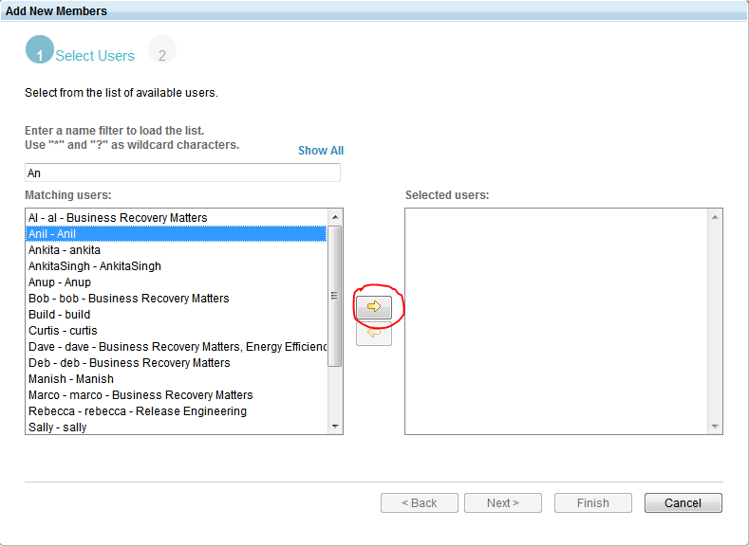

1. Select a name and click on the right arrow to move the user to the **Selected users** area. Then click **Next**.
2. Next we have to assign a role to the selected user. After clicking **Next** in the previous step, you can see the **Available Roles** (as shown in the image below). Select the role you want to assign to the user and click the right arrow.

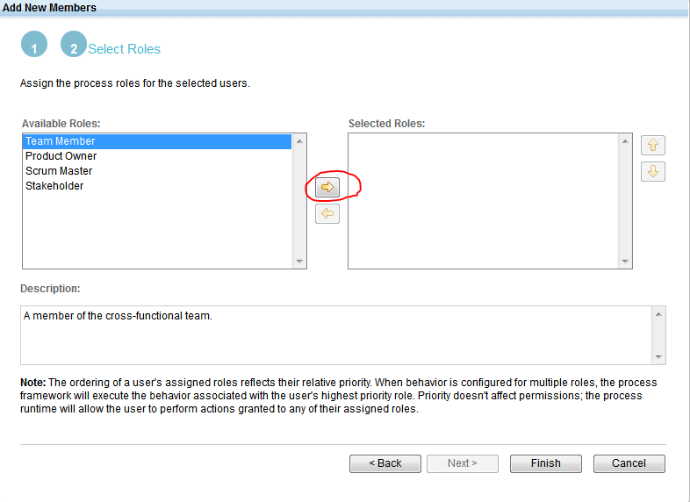

1. After selecting the role click **Finish** and click on **Save** on the project area. Now, you have successfully added a member with a process role to your project area.

CREATING TIMELINE AND ITERATIONS

1. Go to the Project Area of your change management project. In that page click on **Timelines** on the left vertical menu bar. By default there will be the Main Development Timeline, one release (Release 1.0) and two sprints [print 1 (1.0) and Sprint 2 (1.0)].

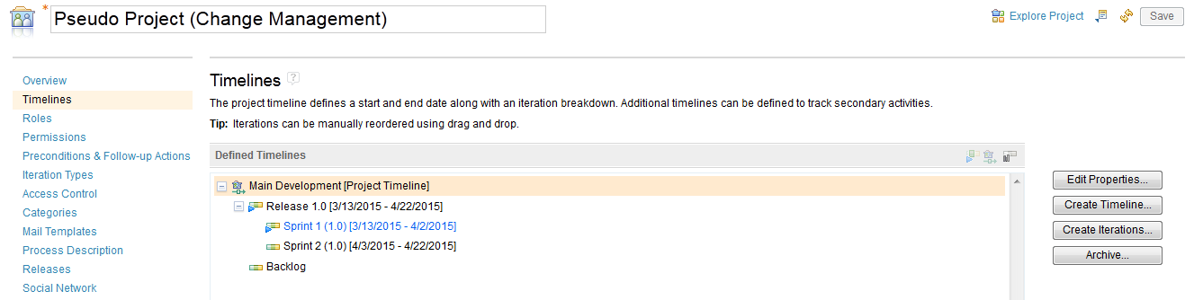

1. To create a new Timeline click on **Create Timeline** (see above picture). After clicking it Create the Timeline window will pop-up. Give a name to your timeline, set the duration, start date, start time and end time for it. Then click **OK** and your timeline will get created.

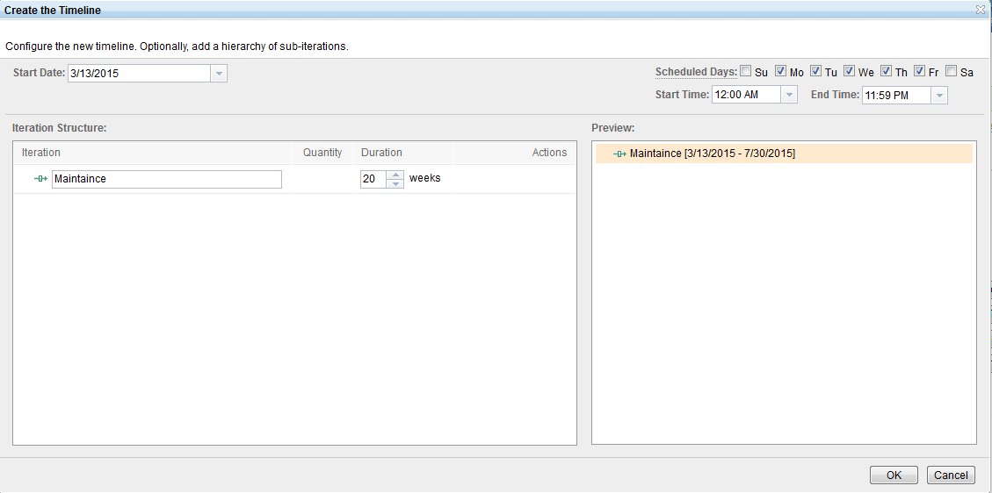

1. Now that there’s a new Timeline, we can add some iterations to it. Select your newly created Timeline and click on **Create Iterations** button and Create the Iteration window will pop-up. First you must create a Release Iteration. Then, you can create child iterations for the Release Iteration as Sprints.

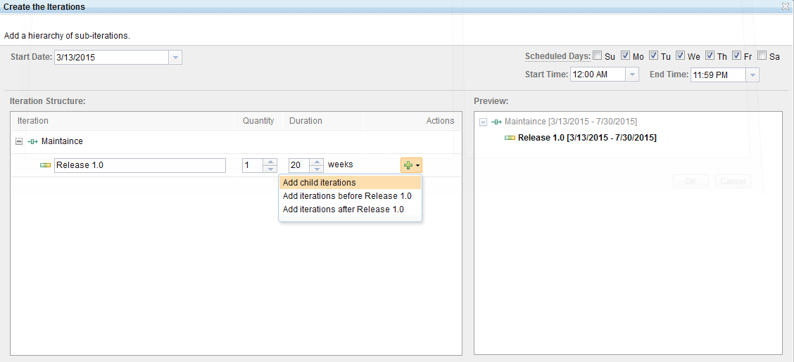

1. Add child iterations as scrums to the Release Iteration and click OK. Then, your iterations for your timeline will be created.

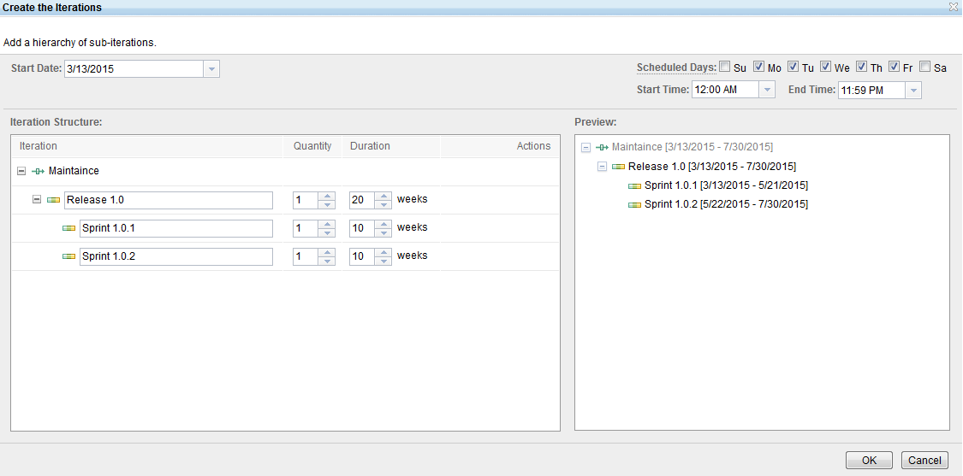

CREATING A TEAM AREA AND ADDING MEMBERS TO TEAM AREA

1. Click on overview to go to project area overview page. In the team hierarchy section click on **Create Team…** option.

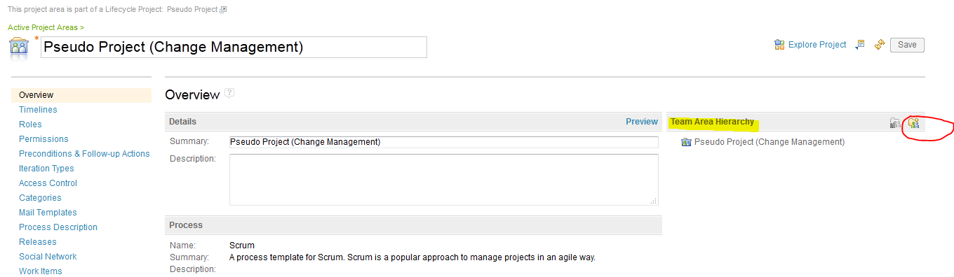

1. Then the Edit Team Area page will appear. Here enter a name to your team area (ex: Web UI Team).

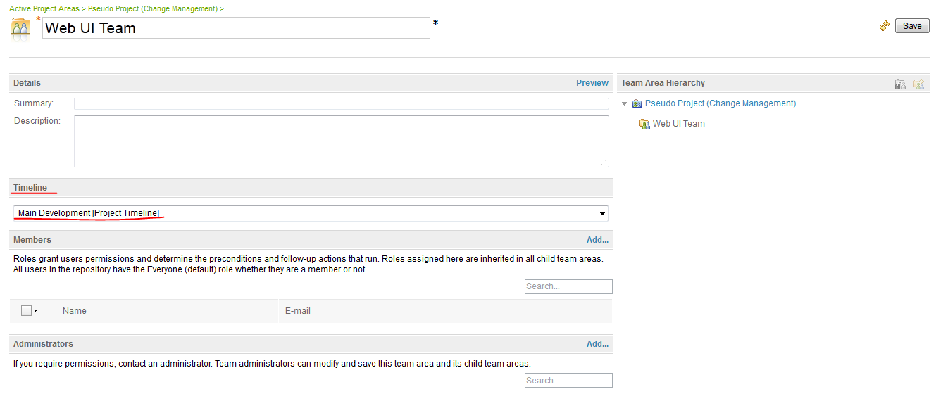

1. Now we are going to add members to the team area. In the Edit Team Area page scroll down to **Members** section and click on **Add…** then a **Select Users** window will pop up. There type a name of the user to add to the team. Select a user and click on **Add and Close** button and the user will be added to team area as a member. You can add more members this way. Then click on **Save** button to save the team area.

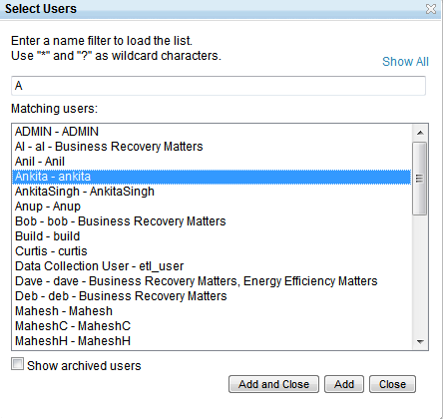

CREATING CUSTOM ROLES

The process template we use for creating the project area defines some process roles by default. We might need to create more roles according to our requirement. For example we want to create a new role called **Trainee,** follow the below steps to create it:

1. Login as administrator and go to your Change Management project’s project area overview page. Then click on **Roles**. Then click on **Add Role** icon (highlighted on the image below).

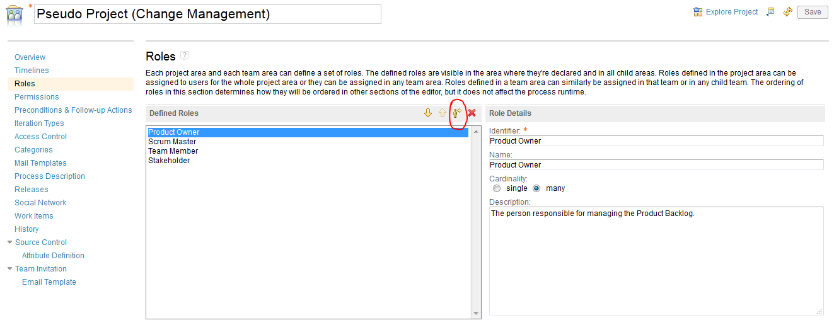

1. Name the new role Intern and specify a similar identifier. The **Cardinality** setting has no effect and is meant provide guidance about whether the role should be assigned to one member or multiple members. Click **Save** to save the project area.

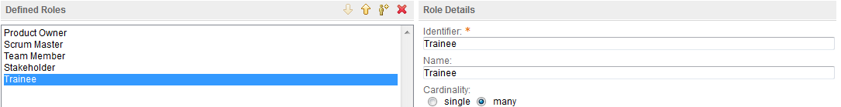

SETTING PERMISSION

By setting permissions we can allow or restrict users in a particular role to perform certain tasks. Let’s set permission for the custom role (Trainee) we created. Follow the below steps to set permission to the Trainee role.

1. Login as administrator and go to your Change Management project’s project area overview page. Then click on **Permissions**. Click **Show by Operation**. Scroll to the **Work Items** category of operations. Expand **Save Work Item** > **Create a work item** >**Create a work item of a specific type**. Select **Create an Epic work item**. To revoke users with the **Trainee** role from creating Epic work items, click the **Revoke Permission** icon  in the action column.

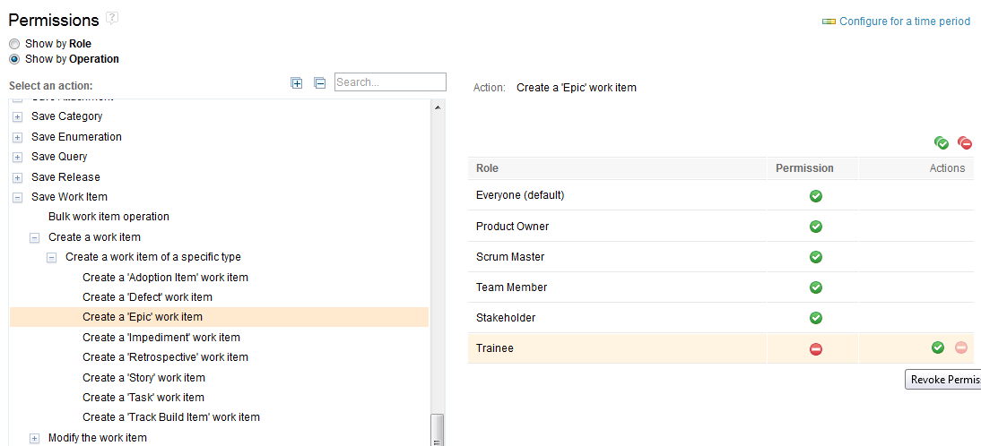

1. Now, click on **Overview**. Then scroll down to the member section and assign **Trainee** process role to a member in your project area. Then save the project area.
2. To see the new setting is in effect, logout and then login as the user to whom you have assigned the Trainee role. Then in the project area click on Work Items. Then from the drop down choose **Epic** as the work item type. Then provide a name to your Epic

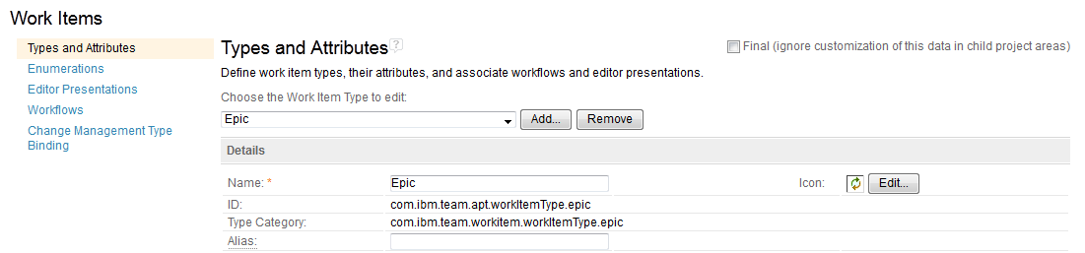

1. Then click on Save and you will receive the following error, because members with Trainee roles are restricted from creating an Epic Work item.



CREATING A PROJECT AREA

We can create a project area in a repository for managing our project, team structures, project process, timelines and iterations.

**USER REQUIRMENTS FOR CREATING A PROJECT AREA**

User must have the repository permission for either **JazzProjectAdmins** group or the **JazzAdmins** group.

*When we create a lifecycle projects it creates various projects area with it. According to the project template selection different Project Areas for Requirements Management, Change Management, Quality Management and Design Management gets created.*

If you want to create a project area for a specific application module, you can create it by following the below steps:

1. Login to the Application Administration panel. Here I am going to create a project area for Change Management. So I am login to CCM application administration panel ([*https://inbasdpc06348.techmahindra.com:9443/ccm/admin*](https://inbasdpc06348.techmahindra.com:9443/ccm/admin)).
2. Navigate to the administration button , click on it and select **Manage Project Areas** from the drop down.

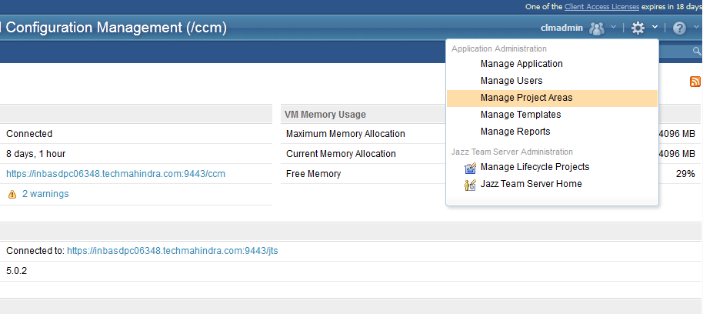

1. After that you will be taken to the **Active Project Areas** page. Then click on Create Project Area button. Then provide a name for the Project Area, select the process template for the project (here I am choosing scrum) and click Save to complete the creation.

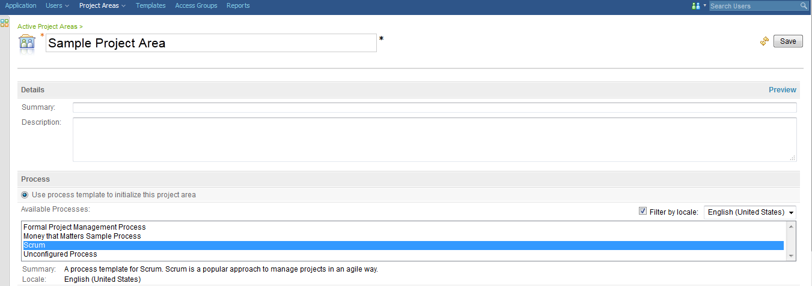

PLANNING AN AGILE PROJECT

Here we are going to plan a project by using the Scrum process template. Agile development approach of software development is characterized by iterations or sprints that basically last 2 to 6 weeks. Each sprint results in delivering some well-functioning code for a specific feature of a product.

Planning a release in an agile project development approach includes following steps:

1. Working from the product backlog. Product backlog is a high level and prioritized list that includes the necessary features to be implemented for a product.
2. Here decision making for which list items to be contained in the upcoming release takes place.
3. Story creation and targeting them for a specific release.
4. Division of works between sprints, creating smaller tasks by breaking the stories and assigning tasks to members of the project.

CREATING A PRODUCT BACKLOG

1. Product owner creates the product backlog. So we have to login as product owner to the Change and Configuration Management web client ([*https://inbasdpc06348.techmahindra.com:9443/ccm*](https://inbasdpc06348.techmahindra.com:9443/ccm)). For Pseudo Project the **User ID** and **Password** for Product Owner is *Kumar* and *Kumar* respectively.
2. After logging in you will be redirected to **All Projects** page. Here I’m creating the Product Backlog for Pseudo Project (Change Management). Click on it and navigate to the project area.

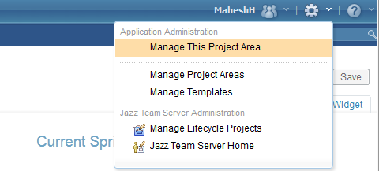

1. On the Project Area page click on **Timelines**. Expand **Main Development Timeline** 🡪 **Release 1.0**

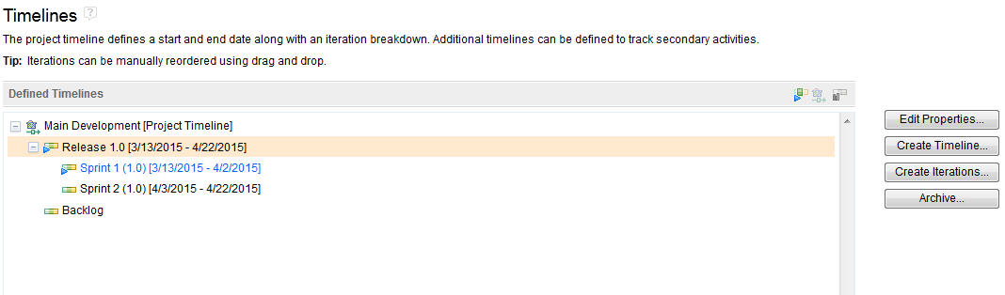

1. To adjust the timeline select **Release 1.0** and click on **Edit Properties** (see the above picture). Then select the date and duration of the release. Click **OK** and then click **Save**.

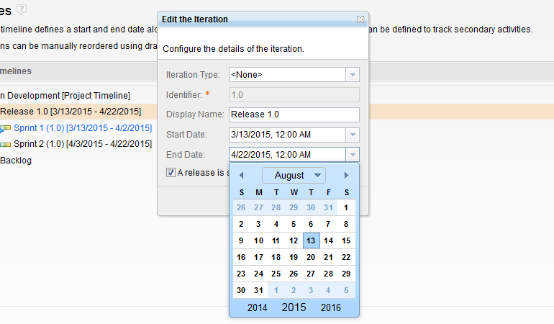

1. Now open the project dashboard by clicking the **Explore Project** () icon.

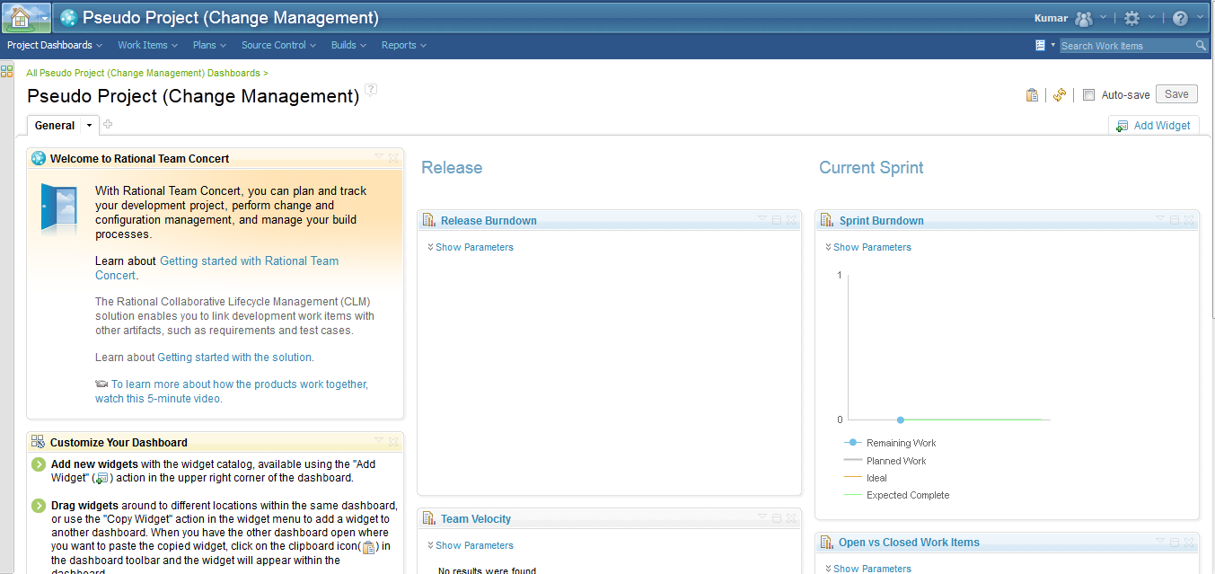

1. Now open the **Product Backlog** of the project. To open the Product Backlog, click on **Plans** 🡪 **All Plans** to see the plans for the project.

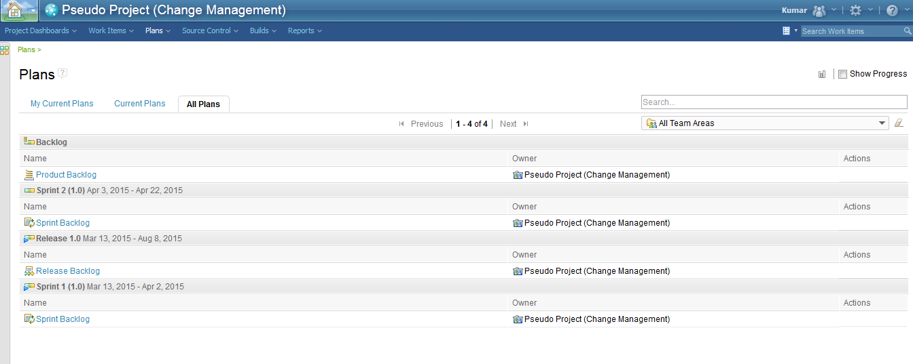

1. In the **Backlog** section click on **Product Backlog**. The plans open in the plan editor.

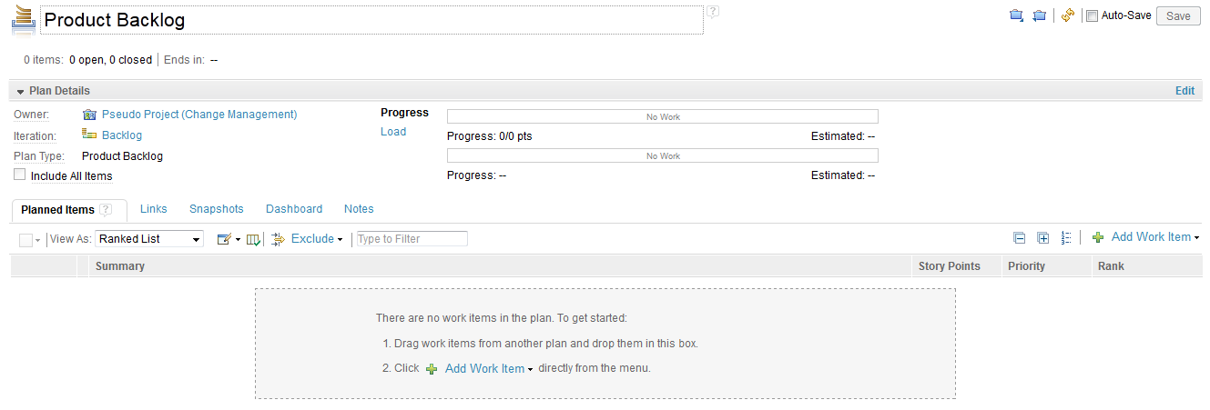

1. Add a story to the plan. As a product owner, you add backlog items, which are called stories, directly on the **Planned Items** tab. A story is a high-level work item in which you can record general details about a product idea or feature. To add a story: click the down arrow that is next to the Add Work Item () icon, and then click Story, type a summary for the story, add at least five stories and click **Save**.

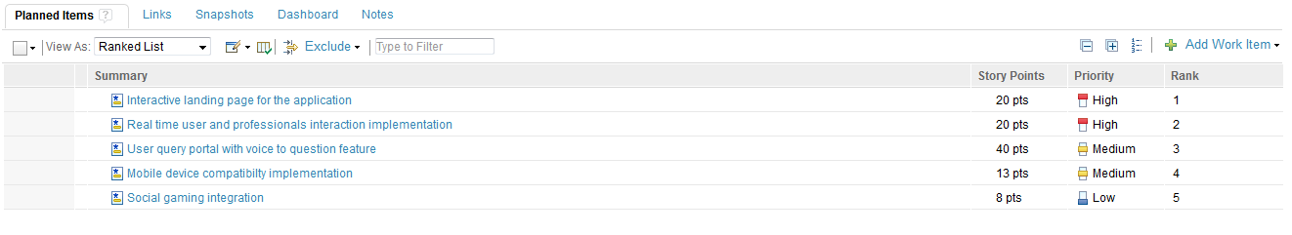

PLANNING THE RELEASE

We just created a product backlog as product owner. Here, again we will continue as the product owner and decide the stories to be accomplished in the release. During release planning, items are pulled from product backlog to the release. The release plan can be revised later and items can be pushed back to the backlog.

Now we will move work items from product backlog to release:

1. Open the Product Backlog by clicking **Plans** 🡪 **All Plans**, and then clicking **Product Backlog**.
2. Hover the mouse pointer over the Actions column of each work item, and select the check box.
3. Move the cursor to the right of each selected check box, and click the down arrow that is next to the Create Work Item () icon.
4. In the menu, hover the mouse pointer over Plan number Plan Items for, where number is the number of work items to move, and click Release 1.0.

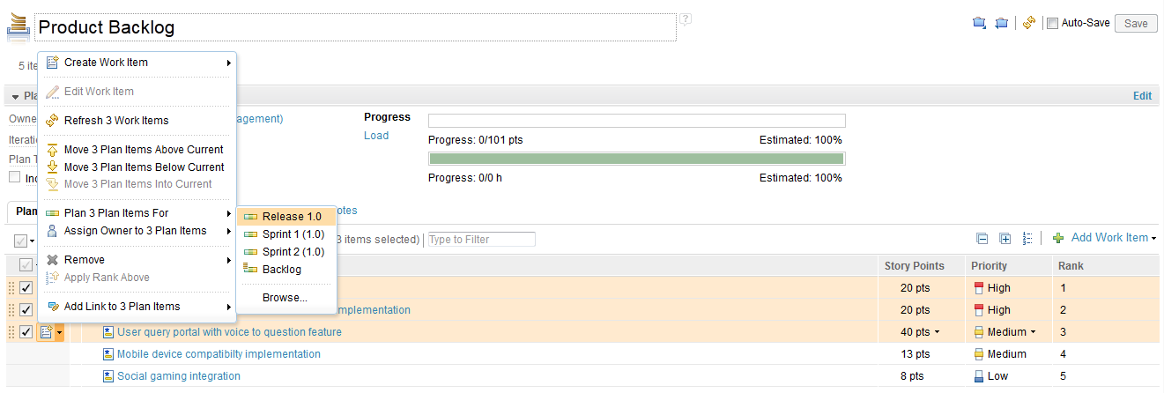

1. And then click **Save**.
2. Now open release backlog of the project by clicking **Plans** 🡪 **All Plans** 🡪 **Release Backlog**

The work items are moved from the product backlog to the release backlog, as the below image shows.

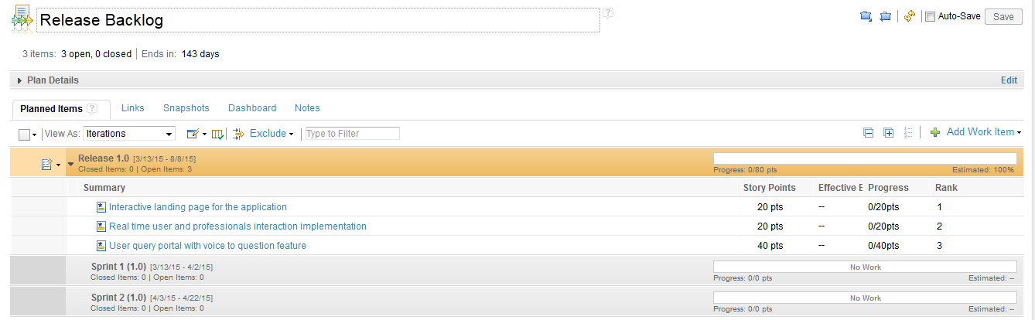

The Progress bar shows a total of 80 points.

On the Planned Items tab, the Iterations view shows the release plan and the first two sprint plans.

PLANNING THE SPRINT

1. The Scrum Master determines what story items to be completed in the release. To plan the sprint we have to login as Scrum Master. In Pseudo Project the Scrum Master User ID and Password is *AnilM* and *AnilM* respectively.
2. Open the release backlog by clicking on **Plans** 🡪 **All Plans** 🡪 **Release Backlog**.
3. Move work items from the release backlog to **Sprint 1**. In the Iterations view, you can drag work items from release to sprint. Hover the mouse pointer over the leftmost section in the Actions column of the work item, and drag the work item to Sprint 1.

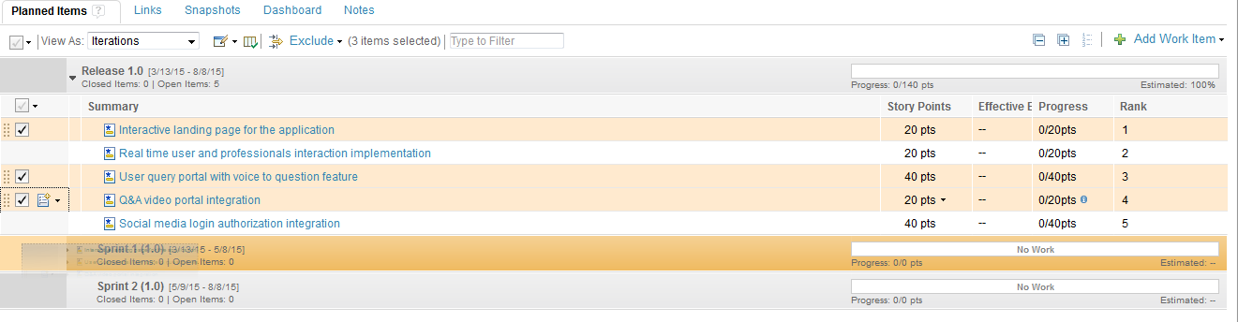

1. The complete the work item for a story, we have to add tasks that will break the work into manageable chunks. Open the Sprint Backlog in the project by clicking **Plans** 🡪 **All Plans** 🡪 and under **Sprint 1 (1.0)** open **Sprint Backlog**.
2. Hover the cursor over the Actions column of the story, click the down arrow that is next to the Create Work Item () icon, click **Create Child Work Item**, and then select Task.

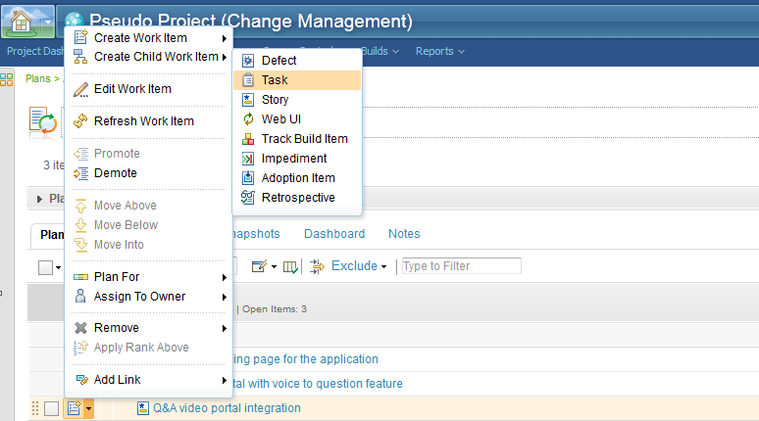

1. Type a summary for the task and add at least three tasks for each story and then click **Save**.
2. Click the task summary to open it in the work item editor.
3. Provide an estimate for the task by clicking the Estimate field, selecting the measure of time, and typing a value. Continue to add estimates for all of the tasks in the story. After you finish estimating tasks, you can see the total estimates for the story and the entire sprint.

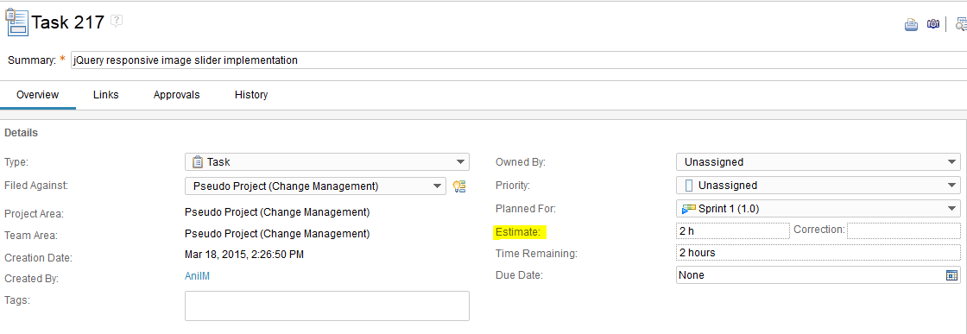

1. Return to the plan by clicking Plans, and under the Recent Plans section, click Sprint Backlog.
2. From the View As list, select Work Breakdown.
3. Expand Unassigned, and then drag each work item to the team member to own it.
4. Monitor the available time for team members as they accept tasks by using the Planned Time view. In the row of each team member, a progress bar displays the work load report.

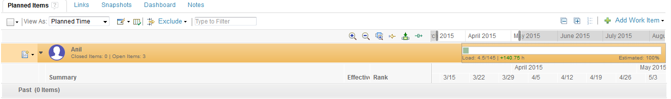

VIEW ASSIGNED WORK

During the sprint, team members start working on their assigned tasks, regularly report how much time remains to complete the tasks, and eventually resolve the tasks. They also track how much work is completed for a task. By reporting on and tracking their work, team members ensure that the correct information about the remaining work in a sprint is presented. Given that the scrum method emphasizes completed work, not started work, start and complete a work item before you move to the next item.

1. To view assigned work we have to login as team member and manage our workload. Here in Pseudo Project I am logging in as Anil, **User ID:** *Anil* and **Password:** *Anil.*
2. Open the sprint backlog in your project by clicking **Plans** > **All Plans**, and in the Sprint 1 (1.0) section, click **Sprint Backlog**.
3. View your workload in the taskboard: on the **Planned Items** tab, from the **View As** list, select **Taskboard**.
4. Modify the Taskboard plan view to look like a developer-style taskboard:
5. Click the **Edit Plan View** () icon, and then click **Edit Taskboard**.
6. Click the down arrow that is next to the **More** () icon, and then click **Group**.
7. In the list on the right, make sure that **Owner** is selected.
8. Click **OK**, and then click **Save**. The taskboard is grouped by owners, as the below image shows.

